**Adagio - Inventory (Enter Product into Inventory)  
*Step 1 of 3***

* Open Inventory Module
* Receipts  
  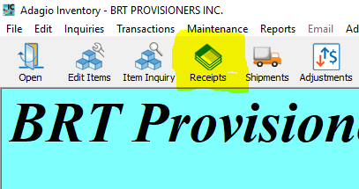
* Edit Receipts window will open, scroll to bottom to see last receipt # used
* Click “NEW” & enter the next receipt #
* Description = Enter PRODUCT NAME (ie. Redfish Frames, Cod, Chicken, etc.)
* Enter Vendor #
* Enter Invoice #
* Date = date of sale (day product is on truck/delivery date)
* Shipped via (Trucking Company used – Palco, John McDonald etc)
* Location of Product – DS = Direct Shipment to customer, Americold – Portland, Americold – Gloucester

**DETAILS TAB (**double click the Blue Line)

* Enter Item Number ie. RFHD ICE DS (use search if you cannot find)   
   **also see Codes Listing (Green Tab in book) broken out by Supplier
* Received = Quantity actually received (in UOM indicated), -- TAB x 2
* Extension = Amount Paid on Vendor Invoice
* Click OK

**TOTALS TAB**

* TAB x 3
* Additional Cost = Enter the total Freight cost (hit “+” to bring up calculator)
* Click POST & YES

**TRANSACTIONS Dropdown at Top of page**

* Receipts / Print Receipts Audit List
* Print Options – Print GL distribution summary (Check the box)
* Hit PRINT button
* Click NO – do you want to clear? Hit PRINT again – click YES & OK
* Close
* Click COMPLETE & YES

**1 copy of Listing is filed in Yellow “INVENTORY” Folder (bottom drawer of cabinet under printer), other copy gets attached to the customer invoice (created in Step 2 “OE – Invoicing Customer”)